PARISH OF BLESSED SACRAMENT & BLESSED TRINITY (www.connahsquaycatholicchurch.org.uk)
Canon Joe Stewart: tel 01244 830358 / mobile 07550079995 / e-mail quayandferry@gmail.com
Convent – tel 01244 830692 / e-mail shoturs@yahoo.co.uk
28th Sunday of Ordinary Time (A) 11th/12th October 2 Day of Prayer for Prisoners & their dependants

Sat 11th October 5.30pm @ CQ Sean Stapleton RIP
Sat 11th October 7.00pm @ CQ Polish Mass
Sun 12th October 9.30am @ QF Beata’s Intention
Sun 12th October 11.00am @ CQ People of the Parish

Mon 13th - 11.00am @ QF Funeral for Jacqueline Michelle Roberts RIP
Tue 14th – 10.00am @ CQ Requiem Mass for Sean Stapleton RIP
Wed 15th - 9.45am @ CQ Novena to Our Lady
“ “ – 10.00am @ CQ St Teresa of Jesus Brian Martin RIP
Thu 16th - 9.30am @ QF Eucharistic Service
Fri 17th - 10.00am @ CQ St Ignatius of Antioch Donor’s Intention
Sat 18th - 9.30am @ QF St Luke Pasquale Ferrara RIP
“ “ - 5.30pm @ CQ
“ “ - 7.00pm @ CQ Polish Mass
Confessions - Saturday after 9.30am Mass @ QF & 5.00pm @ CQ

Church Cleaning Rota CQ
w/c Oct 12th – Sharon, Jeanette & Sue
w/c Oct 19th – Lia & Joyce
Children’s Liturgy of the Word Rota
Oct 12th – Mrs Burns & Mrs Doyle
Oct 19th – Miss Murdoch & Mrs Sullivan
Sunday 11am Bidding Prayers Rota
Oct 12th – R Martin / Oct 19th – A Doran
Oct 26th – A Primrose / Nov 2nd - School

11th/12th October: Mass Statistics Count II
Rosary during October: 15 minutes before each weekday Mass and Sat. 5.30pm Masses; 6.30pm when there is a Polish Mass,

Meeting 12th Oct: after the 11am Mass in the Parish flat to follow-up & discuss the points raised in the previous meeting.
Red Boxes: Please bring to church and give to Mary Kelly or Canon Joe.

Parish Fayre Meeting: Mon. 13th Oct. 7.30 pm in the parish Flat.

Food bank: Please continue generously to bring non-perishable food items to both churches. Many families are still in need.

KSC Race Night: Friday 17th October at St David's Church Hall, Mold @ 7.30pm. Entrance is free, children are welcome & refreshments will be available. All monies raised will be going to the KSC project Mary's Meals. It costs £12.20p to feed a child for a year. Also the 2015 KSC calendars are going on sale, again all profits going to Mary's Meals, you can order them now from Peter Carberry - e-mail pjcarberry@btinternet.com or phone 01352 750102. Please try and support our worthy cause.

Christmas Fayre: takes place this year on 29th November (later than usual due to room being used for a wedding). We will soon be asking for items and goods towards raffle and stalls as usual. Further information at a later date.
Christmas raffle: tickets will be on sale soon. This year we will have a combined Parish raffle with both churches together.

Collection: Last weekend was £257.21 with a further £488.00 from the Gift Aid envelopes. This will give our parish an extra £122.00 we can claim back from tax paid. Please consider giving your offertory in a Gift Aid envelope if you pay tax.
The annual Harvest Fast Day collection in aid of CAFOD is held over for another week as further donations are expected.

Looking ahead: 19th October – annual pilgrimage of St Richard Gwyn, 3.00pm at Wrexham Cathedral. 15th November : 7pm- Polish Mass
World Mission Sunday: . I Will Build My Church!
next weekend (18th/19th Oct) is the annual appeal for the Association for the Propagation of the Faith

Your ongoing support of the Society for the Propagation of the Faith is vital to
the missionaries serving in 1,150 dioceses throughout Asia, Africa, parts of Latin America
and Europe, and on the Islands of the Pacific. Your generosity makes it possible
for local priests, religious, and catechists to reach out to communities, families and
children in desperate need, bringing the light of Christ to the darkest of circumstances.
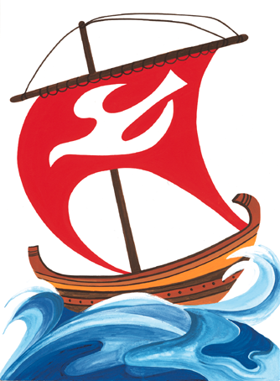Items for the bulletin: to Carmel Smith, tel 01244 830985 or e-mail carmel_smith@sky.com by Weds evening please.

