BLESSED SACRAMENT & BLESSED TRINITY CHURCHES (www.connahsquaycatholicchurch.org.uk)
Canon Joe Stewart: tel 01244 830358 / mobile 07550079995 / e-mail quayandferry@gmail.com
Convent – tel 01244 830692 / e-mail shoturs@aol.com
3rd Sunday of Lent (A) 22nd/23rd March 2014

Sat 22nd March 5.30pm @ CQ Arthur Sparks RIP (FM)
Sat 22nd March 7.00pm @ CQ Polish Mass
Sun 23rd March 9.30am @ QF William Brownley RIP
Sun 23rd March 11.00am @ CQ People of the Parish

Mon 24th - 9.30am @ QF Liturgy of the day Mimo Gioia RIP
Tue 25th – 10.00am @ CQ The Annunciation of the Lord Martha E Morrin RIP (FM)
Wed 26th - 9.45am @ CQ Novena to Our Lady
“ “ – 10.00am @ CQ Liturgy of the day Donor’s Intention
Thu 27th 9.30am @ QF Liturgy of the day Donor’s Intention
Fri 28th – 10.00am @ CQ Liturgy of the day Donor’s Intention
“ “ – 7.00pm @ CQ Stations of the Cross
Sat 29th - 9.30am @ QF Liturgy of the day Donor’s Intention
“ “ - 5.30pm @ CQ
Confessions - Saturday after 9.30am Mass @ QF & 5.00pm @ CQ

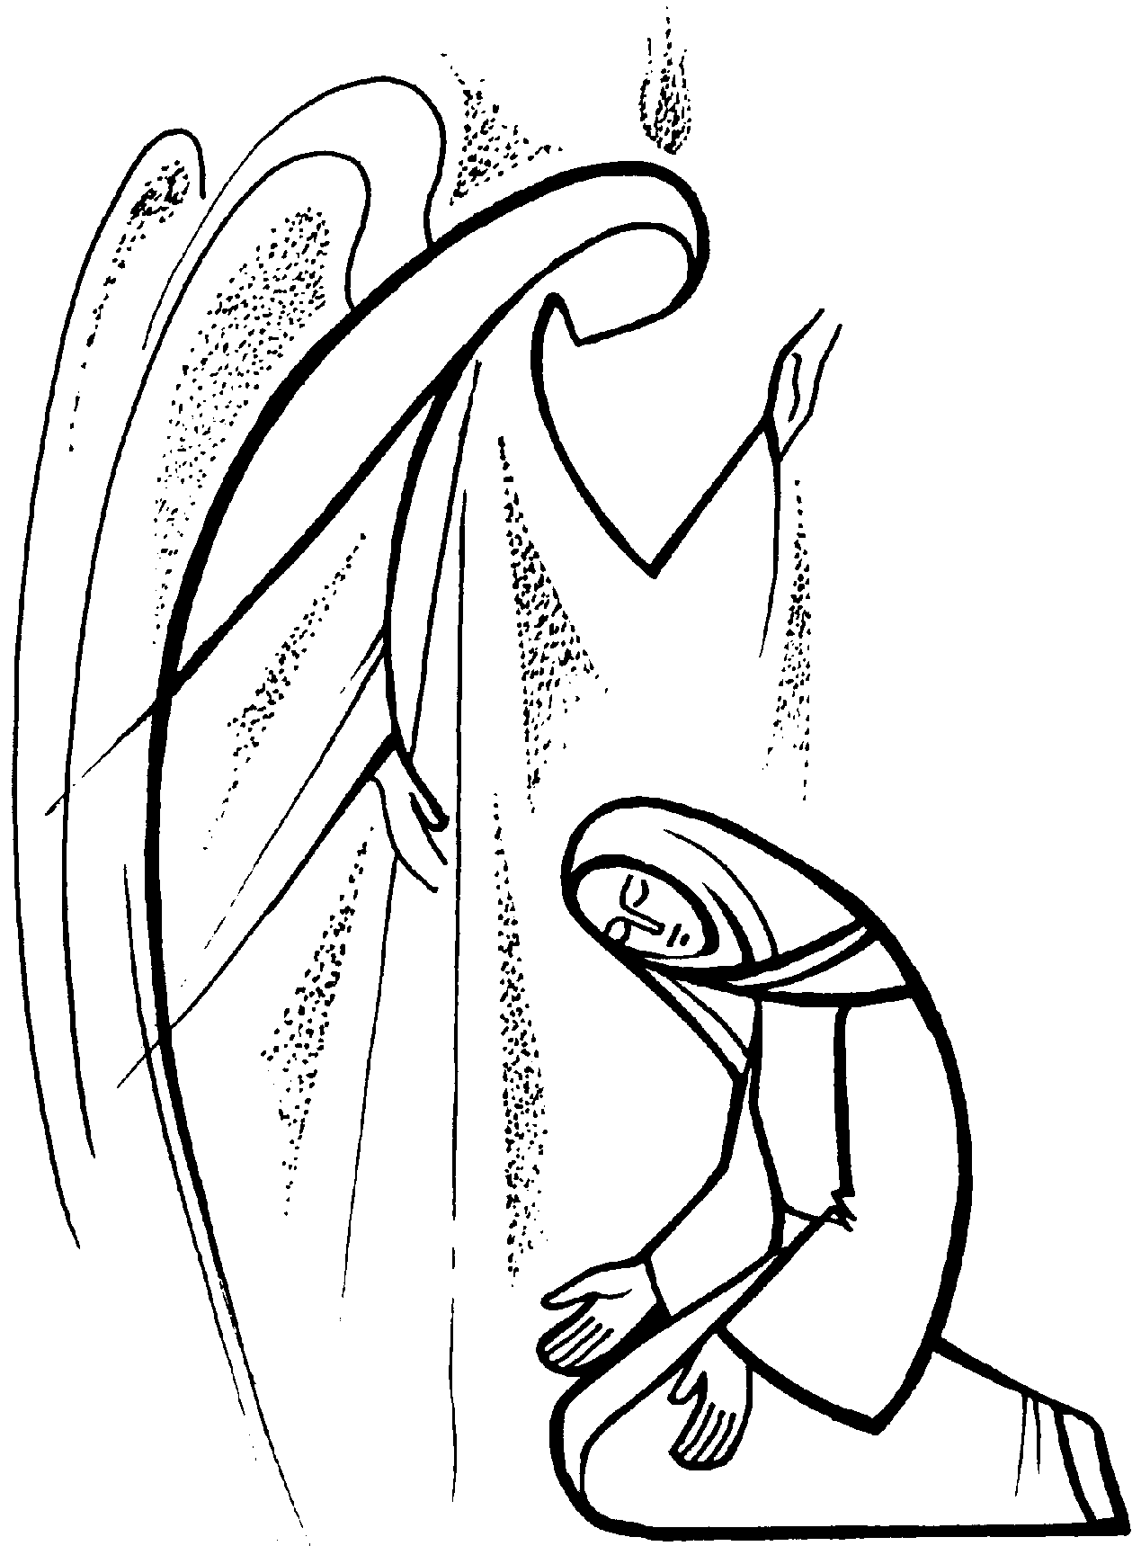

Church Cleaning Rota CQ
w/c Mar 23rd – Sharon, Jeanette & Sue w/c Mar 30th Lia & Joyce

Children’s Liturgy of the Word Rota
Mar 23rd - Mrs Sullivan & Mrs Burns
Mar 30th - Mrs Smith & Miss Murdoch

Sunday 11am Bidding Prayers Rota
Mar 23rd – Jess / Mar 30th – Clair
Apr 6th – Rita / Apr 13th – school

British Summer Time: please remember that the clocks will go forward one hour next Saturday night/Sunday morning (29th/30th).

Churches Together Lent Course: on Wednesdays at 7-8pm in St Andrew's Church, Connah’s Quay. See poster in porch for more details.
Ecumenical Stations: on Mondays during Lent, at 7.30pm in St Ethelwold’s Church, Shotton.

Reconciliation Service: Weds 2nd April, 7.00pm at Blessed Sacrament. Confessions will be heard in both English & Polish.

Bishop Peter’s Visit: Canon Joe would like to thank all who helped during Bishop Peter’s visit.

24 Hours Exposition From 5pm Fri 28th-5pm Sat 29th Mar, Eucharistic Adoration, with the offer of the Sacrament of Penance, has been asked for in at least one church in every diocese. St. David's Church, Mold, will be hosting this Lenten initiative for our whole diocese. At the request of Bishop Peter the six deaneries in the diocese will take responsibility for two x 2 hour slots. Bl.Trinity & Bl. Sacrament parishes are in St Winefride's. Deanery. Our slots are Sat 29th 1.00-3.00am & 3.00-5.00 pm. Canon Joe wishes everyone to know that this is voluntary.
(See Sisters if transport for the night time Exposition can be shared.)

Confirmations: the first meeting for the Confirmandi, parents and/or sponsors takes place on Friday 28th March at 5pm at the Blessed Sacrament Church. The following names have been put forward: Agne Gabriuniate, Olivia and Jack Thorn, Sophie Green, Maddie Thomas, Melissa Primrose, Hannah Knox, Margaret, Catherine and Johnny Purcell and Olivia Rusowicz. Any other candidates who wish to join the program need to inform either Jack Cawley, Paula Palmer or Canon Joe before that date please.

Stations of the Cross at Pantasaph Monastery: The KSC council 614 will be holding their pilgrimage on Good Friday, 18th April. Everyone meets in the car park from 10.30am and the pilgrimage begins at 11.00am prompt, lasting about 45mins. If you require a walking aid please bring it with you, support will also be given if required.
Collection: Last weekend was £214.72 with a further £347.50 from the Gift Aid envelopes. This will give our parish an extra £86.88 we can claim back from tax paid. The CAFOD retiring collection amounted to £343.43.
Looking Ahead: Sat 5th April – Polish Mass @ 7.00pm
Fri 16th May: Race Night for Cafod in The Groves Community Club, Shotton.

Items for the bulletin: to Carmel Smith, tel.01244 830985 or e-mail carmel_smith@sky.com by Weds evening please.

Message from Canon Joe - Following Bishop Peter’s visit to the Parish, and his talk to us about the shortage of clergy, I have decided that this year the Holy Week Services will all be held at Blessed Sacrament, the 9.30am Mass on Easter Sunday will be at Blessed Trinity as normal. I encourage all parishioners to play a full & active part in the liturgy of Holy Week. The Paschal Triduum services will be:-
Thursday 17th April – Holy Thursday – 7.00pm (CQ)
Friday 18th April – Good Friday – 3.00pm (CQ)
Saturday 19th April – Holy Saturday Vigil – 7.00pm (CQ)
Sunday 20th April – Easter Sunday – 9.30am (QF) & 11.00am (CQ)

