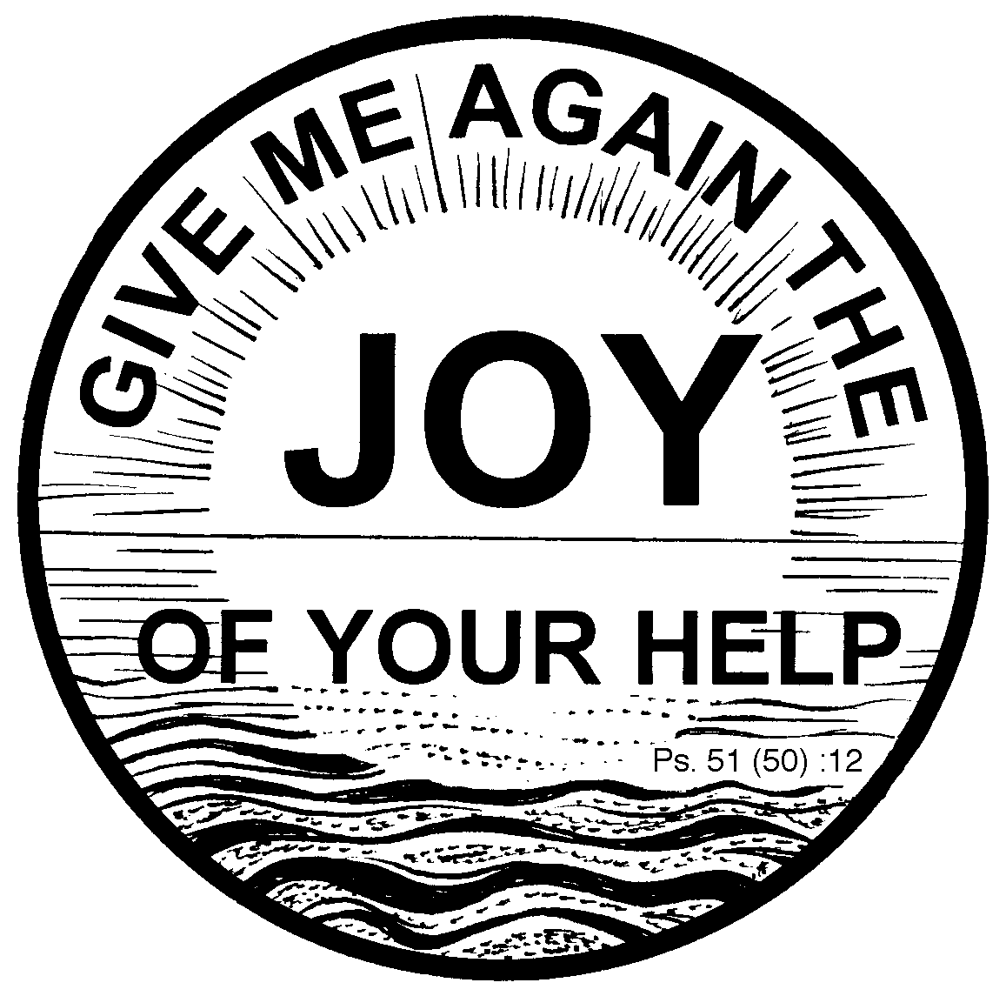

BLESSED SACRAMENT & BLESSED TRINITY CHURCHES (www.connahsquaycatholicchurch.org.uk)

Canon Joe Stewart: tel 01244 830358 / mobile 07550079995 Convent – tel 01244 830692

The Holy Family of Jesus, Mary and Joseph (A) 28th/29th December 2013
Sat 28th December 5.30pm @ CQ Sally & Jimmy Morgan
Sun 29th December 9.30am @ QF Deceased parents & family of Belinda Stone
Sun 29th December 11.00am @ CQ People of the Parish

Mon 30th - 9.30am @ QF Sixth Day with the Christmas Octave Vera Baker RIP
Tue 31st – 10.00am @ CQ Seventh Day with the Christmas Octave Michael & Christopher Bithell RIP
Wed 1st - 9.45am @ CQ Novena to Our Lady
Wed 1st – 10.00am @ CQ Mary Mother of God Green family and Jim Healy & family
Thu 2nd – 9.30am @ QF Ss Basil the Great& Gregory Nazianzen Kathleen Garvey & family
Fri 3rd – 10.00am @ CQ The Most Holy Name of Jesus Sheila Smith RIP
Sat 4th - 9.30am @ QF Weekdays before Epiphany Maxine Boswell RIP
Confessions - Saturday after 9.30am Mass @ QF & 5.00pm @ CQ
-5.30pm @ CQ
-7.00pm @CQ Polish Mass

Church Cleaning Rota CQ
w/c Dec 29th – holiday from cleaning
w/c Jan 5th – Lia & Joyce
Children’s Liturgy of the Word Rota
Dec 29th – No Children’s Liturgy
Jan 5th – Mrs Palmer & Miss Palmer
Sunday 11am Bidding Prayers Rota
Dec 29th – Jess / Jan 5th - tba

Canon Joe would like to thank all parishioners for their help & support over the last 12 months, and also to thank everyone for their cards & gifts.
Canon Joe also wants to thank all who have helped to prepare the churches for Christmas, those who have served and everyone who has taken part in the Masses.
Prayers please :for the repose of the soul of Florence Connors, who died on Christmas Day, RIP, and for Emmanuel Jolly who is sick.
Polish Masses: the next Polish Mass will be celebrated on Saturday, 4th January at 7pm. and then 7pm Saturday, 18th January.

Flintshire Foodbank: QF - Mondays from 10.00-12.00 at John Summers Community Campus. CQ - Fridays from 10.00-12.00 at the Salvation Army Citadel. Please take food donations to the collection points, if this is not possible please leave your donations in the Church porches.

Light and Life: Pantasaph Retreat: Fri 28th Feb-Sun, 2nd March. Centred on devotion to the Divine Mercy given by Fr. Airton Freire from Brazil. Deposit: £25. Total offering: £90 per person / 2 nights (full board) –details in porch.

Gift Aid Our parish has received a cheque for £4,913.32 from the tax authorities for Gift Aid donations
made during the financial year April 2012 to April 2013. Anyone who pays tax, would you please consider giving your offertory collection through the Gift Aid scheme. Gift Aid forms are available after Mass in the church porch, the only requirement is your name, address and signature. Please don't let this money go to waste, we have lost several donors this past year for various reasons and we need to make up the short-fall.
Collection : Last weekend was £332.34 with a further £359.40 from the Gift Aid envelopes. This will give our parish an extra £89.85 we can claim back from tax paid. Please consider giving your offertory in a Gift Aid envelope if you pay tax. The amounts shown each week are the combined totals from both Connah's Quay and Queensferry churches.

Items for the bulletin: to Carmel Smith, either telephone 01244 830985 or e-mail carmel_smith@sky.com by Weds evenings please.

