PARISH OF BLESSED SACRAMENT & BLESSED TRINITY

www.connahsquaycatholicchurch.org.uk www.fb.me/deesidecatholic
Canon Joe Stewart: tel 01244 830358 / mobile 07550079995 / email priestcquay@rcdwxm.org.uk
Good Shepherd Sunday - 4th Sunday of Easter (B) 24/25th April 2021
Wrexham Diocese Charity Number 700426

+

Sat 24th April 5.30pm @ CQ 4th Sunday of Easter Colin Neave RIP (Stewards – K Morris, J Baker)
Sun 25th April 9.30am @ QF “ “ “ “ Imelda Mathews (60th Birthday) (Stewards – D & C Fellows, P & C Field)
Sun 25th April 11am @ CQ “ “ “ “ People of the Parish (Stewards – A Thomas, C Murdoch)

Tues 27th April 9.30am @ QF Liturgy of the Day Molly & John Barker RIP (Stewards – P & C Field)
Wed 28th April 10am @ CQ Liturgy of the Day Christina Quigley RIP (Stewards – C Murdoch, K Morris)
Thu 29th April 9.30am @ QF St Catherine of Siena Butler Family (Stewards – D & C Fellows)
Fri 30th April 10am @ CQ Liturgy of the Day Deceased Members of Evans Family (Stewards – P Thornton, L Voas)
Sat 1st May 5.30pm @ CQ 5th Sunday of Easter Deceased Members of Ward Family (Stewards – K Morris, J Baker)
Sun 2nd May 9.30am @ QF “ “ “ “ Nino Muia RIP (Stewards – D & C Fellows, P & C Field)
Sun 2nd May 11am @ CQ “ “ “ “ People of the Parish (Stewards – S Copp, L Voas)

Rotas at Connah’s Quay
Readers: 24th/25th Apr : 5.30pm – Griffiths Family 11.00am – R Martin
1st/2nd May : 5.30pm – W Griffiths 11.00am – B Bowden

If anyone wants a virtual copy of the bulletin, please email Canon Joe to give permission. This is to comply with GDPR regulations.

You can follow live streaming of Mass & other services from Bishop Peter via the Diocesan Facebook page - https://www.facebook.com/wrexhamdiocese/ There are also links to other Churches in the Diocese who are streaming Masses.

Please Pray For:-
- Gerard O’Sullivan, who is recovering from an operation
- Julia Healy, who is now home from hospital
- Margaret Parkinson who is in hospital
- Christine Maughan who is ill, and her husband Kevin & family members
- All the sick of the Parish.

A FURTHER REMINDER OF MASS RULES – PLEASE ALSO REMEMBER TO FOLLOW ALL THE INSTRUCTIONS GIVEN BY THE STEWARDS
- When people come into Church, they must first wash their hands. 2. People MUST stay 2m apart (unless from the same household).
- Face masks are mandatory unless you are exempt from wearing one. 4. The maximum number permitted at Mass will be 35
- Mass will be much shorter than usual – there will be no singing, and Communion will be given out at the end of Mass.

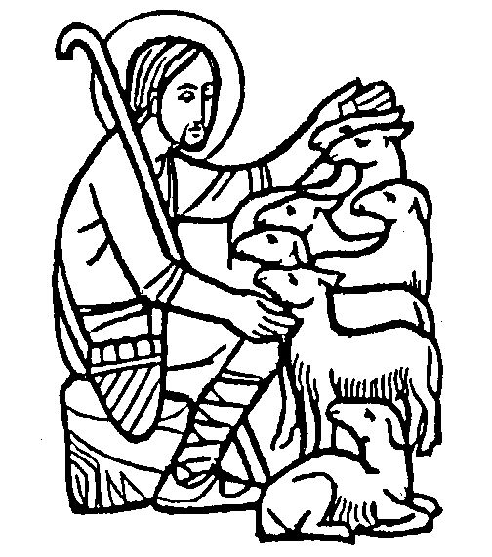

Good Shepherd Sunday is World Day of Prayer for Vocations. The purpose of this day is to publicly fulfil the Lord's instruction to, "Pray the Lord of the harvest to send labourers into his harvest. Please pray that young men and women hear and respond generously to the Lord's call to the priesthood, diaconate, religious life, societies of apostolic life or secular institutes.

A Message from CAFOD: Thank you for your generous donations to CAFOD’s Family Fast Day during Lent. We featured Marian and her son Svondo in Zimbabwe in Lent 2018. The community vegetable garden that your donations helped provide is growing well and during the pandemic the family has survived on the vegetables. Your support has also helped to provide soap and handwashing stations in the garden and in family homes. This is just one of many long-term development projects that CAFOD has funded with the money from that Fast Day.

The OXFAM shop in the Daniel Owen Centre in Mold has re-opened and has 50% discount on a lot of their stock. They are also looking for volunteers to help sort donations and to serve in the shop. Please call in and see them if you can help.

Collections for Church Funds: Total collections:- 17th/18th Apr CQ £63.18, Gift Aid £265.00, QF 11th Apr £119.50, Gift Aid £37.00, 18th Apr £99.50, Gift Aid £30.00
There will be a retiring collection next weekend, 01st/02nd May, for the Church Students Fund. The Diocese currently has 1 candidate for the priesthood, Matthew Bond, who is studying at the Beda College in Rome.
You may wish to set up a Standing Order to give your donations regularly – please contact Canon Joe for bank details.
Please consider giving your offertory collection in a Gift Aid envelope if you pay tax (a higher rate tax payer can obtain a further 20% tax relief).

Items for the bulletin: to Ann Payton by Weds evening please, tel 01244 821010 or e-mail ann.dragonden@btinternet.com

