PARISH OF BLESSED SACRAMENT & BLESSED TRINITY

www.connahsquaycatholicchurch.org.uk www.fb.me/deesidecatholic
Canon Joe Stewart: tel 01244 830358 / mobile 07550079995 / e-mail quayandferry@gmail.com
2nd Sunday of Easter – Divine Mercy Sunday (A) 19th April 2020
Wrexham Diocese Charity Number 700426

Canon Joe will say Mass each day for the following intentions:-

Sat 18th April Easter Saturday People of the Parish
Sun 19th April 2nd Sunday of Easter People of the Parish
Mon 20th April Monday of the 2nd Week of Eastertide Rachael Knox RIP
Tue 21st April St Anselm of Canterbury Alan Walmsley RIP
Wed 22nd April Wednesday of the 2nd Week of Eastertide Pat Thornton’s intention for Vicky & Baby
Thu 23rd April St George, Martyr Ann Delisle RIP
Fri 24th April Friday of the 2nd Week of Eastertide Mary Kelly (ill)
Sat 25th April St Mark the Evangelist Gerry Burns
Sun 26th April 3rd Sunday of Easter People of the Parish

CHURCHES ARE CLOSED TO ALL ACTS OF WORSHIP UNTIL FURTHER NOTICE
by order of the Bishops’ Conference of England and Wales (www.cbcew.org.uk)

Our parish now has a Facebook page – if you are on FB come and like the page and join us on www.fb.me/deesidecatholic - share your posts and photos there and invite your friends

The Diocese of Wrexham (www.rcdwxm.org.uk) have a Facebook page - https://www.facebook.com/wrexhamdiocese/ and a YouTube channel - https://www.youtube.com/channel/UCGvWVUTM8wQ3AfMuS4rXbPQ where you can follow Bishop Peter live streaming Mass and other services, and also access videos of Mass.

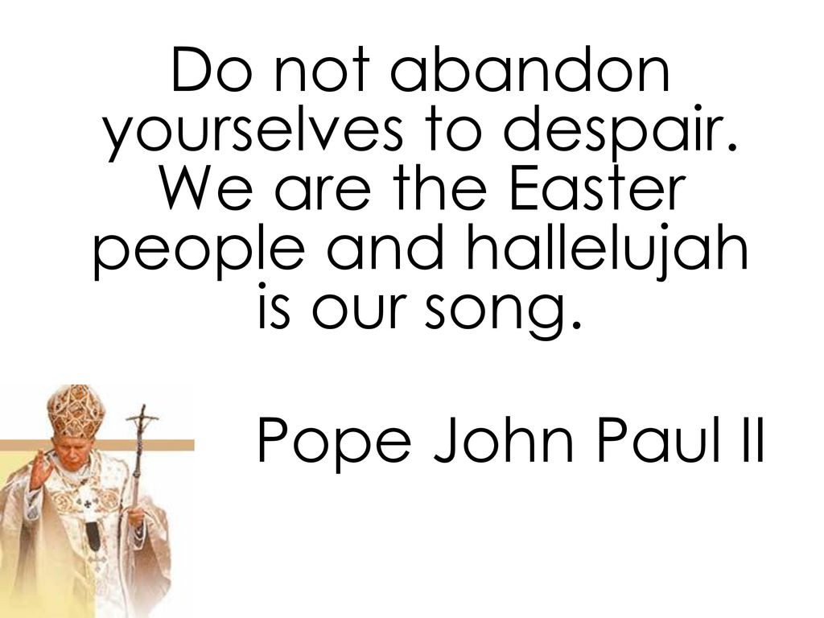

Canon Joe sends his best wishes - he is still well but self-isolating, and he remembers all of us in his prayers and daily Masses.

Please Pray For Rosemary Bowden, who is poorly in hospital, and for her husband Brian and their family.

49 Club – Connah’s Quay Although we can’t currently attend Mass, the club is still running – using the National Lottery Saturday Draw Bonus Ball as always. If you normally pay weekly or monthly by cash or cheque – could you hold on to your subs till we’re back to normal, or alternatively, you can set up a Standing Order with your bank to pay monthly and make it easier. If you’d like to do this, or have any other queries, please contact Marilyn Jones on 07938854835
As it is difficult to get out and about at the moment Marilyn will pass any winnings on when it is possible.

First Holy Communion, Getting To Know You Sessions, PAC Meeting and SVP Meetings are all cancelled until further notice.

Collections for Church Funds: Our Churches’ expenses are still continuing during this Coronavirus crisis – Canon Joe would be very grateful if people could continue donating and putting the money to one side or in their Gift Aid envelopes – these could then be dropped into Church when it is fully open again.
You may wish to set up a Standing Order to give your donations regularly – please contact Canon Joe for bank details.

Items for the bulletin: to Ann Payton by Weds evening please, tel 01244 821010 or e-mail ann.dragonden@btinternet.com

